**Uploading an Assignment via VPL   
System Practitioner Side Manual**

**Introduction**

This manual provides step-by-step instructions for practitioners to upload a new programming assignment via the Virtual Programming Lab (VPL) system using a GitHub URL or a Zip file. This process is designed for programming languages such as C, C++, Python, or C#.

**Step 1: Log in to Moodle**

1. Access the Moodle website.
2. Navigate to the specific course where you intend to upload the assignment.

**Step 2: Enable Edit Mode**

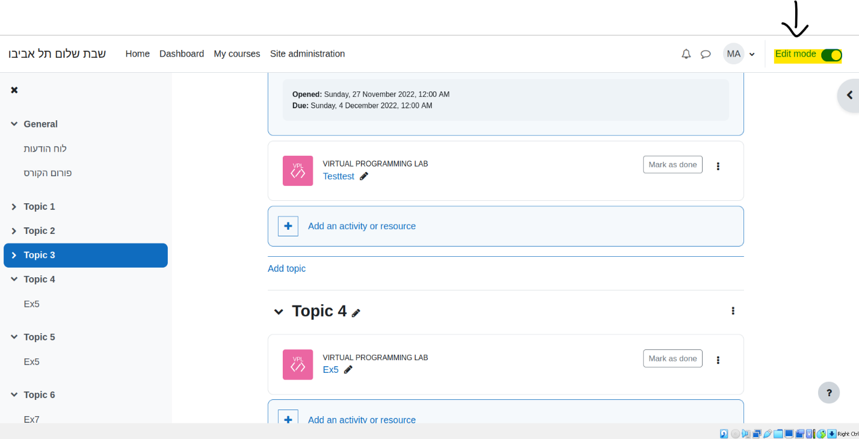Before making any changes, ensure you are in edit mode to modify the course content as needed.

**Step 3: Select Virtual Programming Language Option**

1. Choose the option to add a new activity or resource within the course.
2. **A screenshot of a computer

   Description automatically generated**Select the "Virtual Programming Language" option for the new assignment upload.

**Step 4: Provide Assignment Details**

1. Fill in all necessary assignment details on the subsequent page. Include the assignment name, due date, and any other relevant information.
2. Indicate the number of files required for the assignment.
3. Click the "Save and Display" button to proceed.

**Step 5: Configure Submission Type**

1. Click on the "Requested file" tab within the assignment settings.
2. Specify the name and file type of the submission students are required to upload.

* If the submission is via Git, create a text file (e.g., file.txt) and instruct students to provide a link to their Git repository.
* If the submission is via Zip file, create a zip file (e.g., files.zip) and instruct students to upload a compressed directory containing all necessary files.

1. Save your changes by pressing "Ctrl + S" or using the applicable save option.

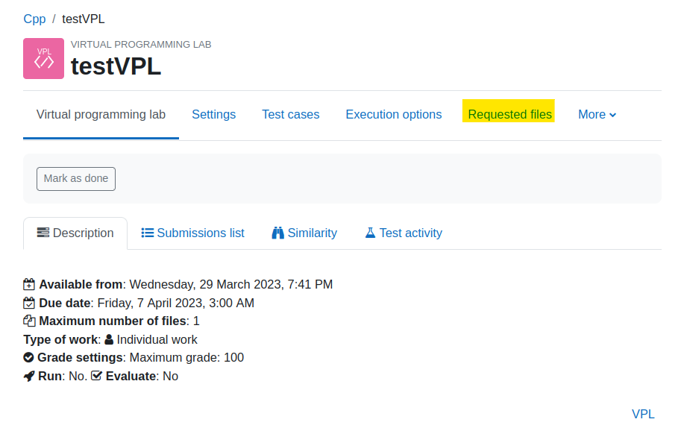

**Step 6: Configure Execution Options**

1. Click on the "Execution Options" section within the assignment settings.
2. Adjust the state of the request modes according to your preferences:

* Run: Allows students to run their program while submitting the assignment.
* Debug: Enables students to debug the program during the submission process.
* Evaluate: Permits students to evaluate their program upon assignment upload.
* Evaluate Just on Submission: Allows students to evaluate their program only upon submission.
* 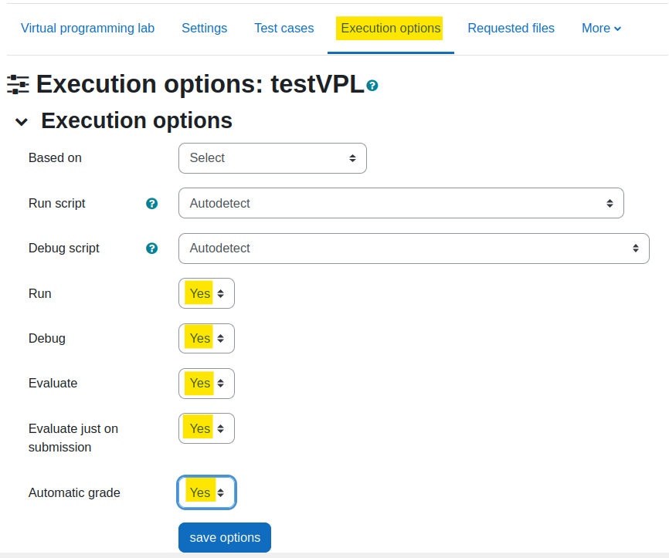Automatic Grade: Enables automatic grading by the VPL jail server without lecturer or teacher approval.

**Step 7: Configure Execution Files**

1. Click on the "More" tab within the assignment settings.
2. **A screenshot of a computer

   Description automatically generated**Select "Execution Files" from the options.

**Step 8: Choose Execution Files**  
For each programming language and submission type:

1. Choose the appropriate zip file from the provided directories.
2. Import the chosen files into the VPL Execution files to ensure proper execution and evaluation.

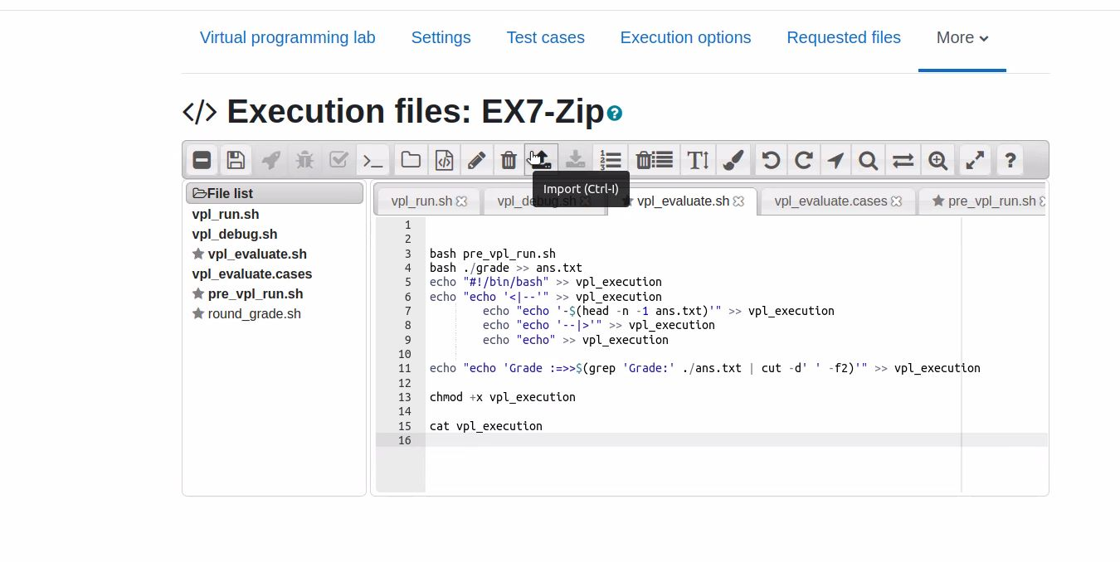**(Note: For Python programs with tests,   
ensure that all test file names end with _test.py).**

**Step 9: Customize Directory File Names**

1. The teacher has the option to modify the default names of directory files within the **pre_vpl_run.sh** script that was imported earlier.
2. 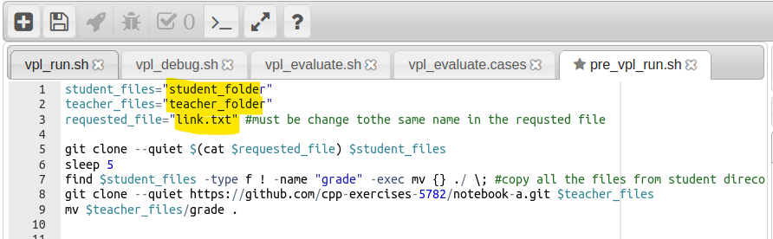Ensure that the requested file name matches the same file name chosen in Step 6 (requested file).

**Step 10: Teacher Review and Automatic Grading**

1. From the teacher's side, the system automatically grades the student's submission based on their self-evaluation.
2. 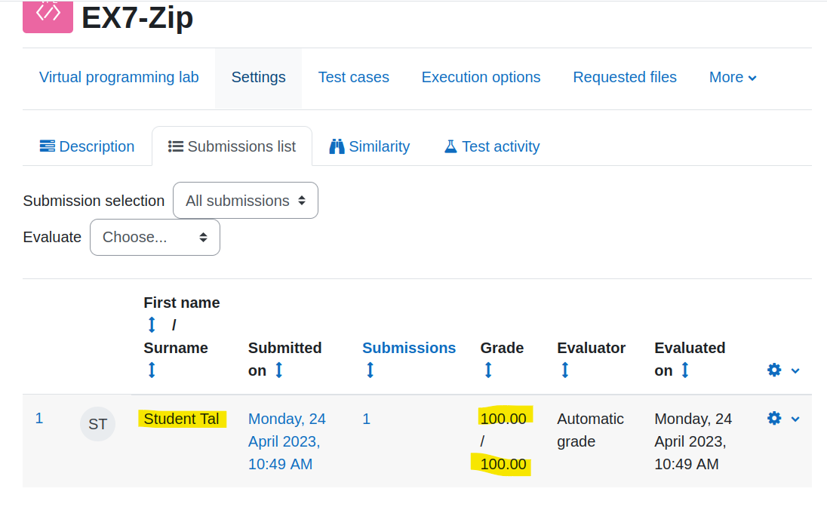The teacher can access the student's submission by clicking on the "Setting Click" and then "Submission View."